**Java GUI Code Examples**

1. **Creating the Window**

import javax.swing.JFrame;

public class FirstGui extends JFrame{

public static void main (String args[]){

FirstGui gui=new FirstGui();

gui.setDefaultCloseOperation(JFrame.EXIT_ON_CLOSE);

gui.setTitle("My First Swing Lab ClassS");

gui.setSize(400, 200);

gui.setVisible(true);

}

}

**Output**

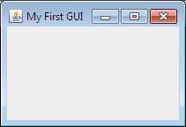

1. **Adding objects to the window**

import javax.swing.*;

import java.awt.*;

public class FirstGui extends JFrame{

private JLabel label1, label2,label3;

private JTextField textfield1;

private JPasswordField textfield2;

private JButton button;

public FirstGui(){

setLayout(new FlowLayout());

label1=new JLabel("Username: ");

label2=new JLabel("Password: ");

label3=new JLabel("Welcome to First Page of Our Application");

**Output**

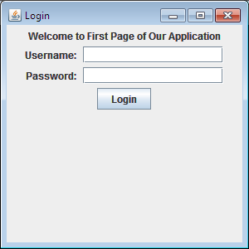

textfield1= new JTextField(15);

textfield2= new JPasswordField(15);

button=new JButton("Login");

add(label3);

add(label1);

add(textfield1);

add(label2);

add(textfield2);

add(button);

}

public static void main (String args[]){

FirstGui gui=new FirstGui();

gui.setDefaultCloseOperation(JFrame.EXIT_ON_CLOSE);

gui.setTitle("Java GUI Program");

gui.setSize(300, 300);

gui.setVisible(true);

}

}

1. **Adding Images**

**Output**

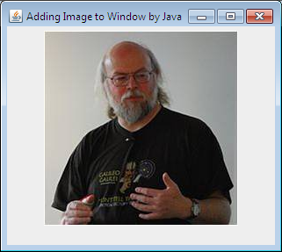

import javax.swing.*;

import java.awt.*;

public class AddImage extends JFrame{

private ImageIcon img;

private JLabel label;

public AddImage(){

setLayout(new FlowLayout());

img=new ImageIcon(getClass().getResource("Gosling.jpg"));

label=new JLabel(img);

add(label);

}

public static void main (String [] args){

AddImage myImg=new AddImage();

myImg.setDefaultCloseOperation(JFrame.EXIT_ON_CLOSE);

myImg.setTitle("Adding Image to Window by Java");

myImg.setSize(400,400);

myImg.setVisible(true);

//myImg.pack();

}

}

1. **Menus**

import java.awt.event.*;

import javax.swing.*;

import java.awt.*;

public class Menu extends JFrame{

JMenuBar menubar;

JMenu file, edit, view, navigate, source, run, window;

JMenuItem exit;

public Menu(){

setLayout(new FlowLayout());

menubar=new JMenuBar();

setJMenuBar(menubar);

file=new JMenu("File");

edit =new JMenu("Edit");

view =new JMenu("View");

navigate =new JMenu("Navigate");

source =new JMenu("Source");

run =new JMenu("Run");

window =new JMenu("Window");

menubar.add(file);

menubar.add(edit);

menubar.add(view);

menubar.add(navigate);

menubar.add(source);

menubar.add(run);

menubar.add(window);

exit=new JMenuItem("Exit");

file.add(exit);

event e=new event();

exit.addActionListener(e);

}

public class event implements ActionListener{

public void actionPerformed(ActionEvent e){

System.exit(0);

}

}

public static void main (String [] args){

Menu myMenu=new Menu();

myMenu.setDefaultCloseOperation(JFrame.EXIT_ON_CLOSE);

myMenu.setTitle("Menu");

myMenu.setSize(400,400);

myMenu.setVisible(true);

//myImg.pack();

}

}

**Output**

